Ranczo

455395

# Ranczo

“*Ranch*” is a Polish television comedy series, directed by [*Wojciech Adamczyk*](https://en.wikipedia.org/w/index.php?title=Wojciech_Adamczyk&action=edit&redlink=1), that originally aired from March 25, 2006 to November 27, 2016 on [*TVP1*](https://en.wikipedia.org/wiki/TVP1). It follows the story of *Lucy Wilska*, a [*Polish-American*](https://en.wikipedia.org/wiki/Polish-American) who has inherited her grandmother’s country home in the fictional small village of *Wilkowyje*. She arrives in *Wilkowyje* with intent to sell the cottage but, after seeing the charm of the village, decides to stay. - Source: *Wikipedia*

## Picture

|  |
| --- |
| Ranczo picture |

## Viewers

| Season | AVG.Viewing |
| --- | --- |
| 1 | 4 101 154 |
| 2 | 6 857 229 |
| 3 | 6 898 190 |
| 4 | 8 283 864 |
| 5 | 6 676 405 |
| 6 | 6 226 339 |
| 7 | 6 328 780 |
| 8 | 6 152 526 |
| 9 | 5 997 064 |
| 10 | No Data |

## View table

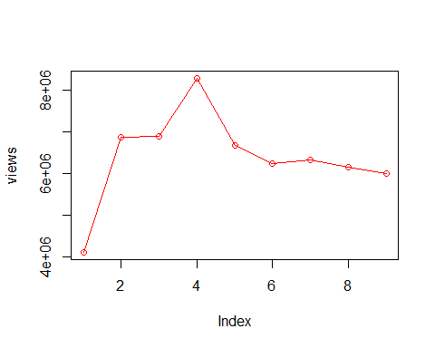

## Conclusion on views

Between season 1 and 2 the views increased by 2.756075^{6} which was the greatest change in the shows history.